THEORY OF ISOSPATIAL REFLEXIVE DIMENSIONS (TIRD)
A Unified Framework for Coexistent Mirror States Occupying a Single Spacetime Coordinate

Earth Angel Ventures Master Scientific Research Paper
Status: Hypothesis and Experimental Protocol Document
No empirical data have been collected yet. No results are reported or implied yet

1. DOCUMENT CONTROL AND FRONT MATTER

Field | Entry
Full Title | Theory of Isospatial Reflexive Dimensions (TIRD): A Unified Framework for Coexistent Mirror States Occupying a Single Spacetime Coordinate
Short Title | Theory of Isospatial Reflexive Dimensions (TIRD)
Document Classification | Research and Development - Theoretical Model with Experimental Protocols
Research Program | Consciousness, Quantum Information, and Multidimensional Structure
Project ID | EAV-TIRD-001
Manuscript ID | EAV-TIRD-001-M01
Research Status | Hypothesis / Protocol. No empirical data collected.
Date | 20 October 2026
Primary Discipline | Theoretical Physics and Consciousness Science
Secondary Disciplines | Quantum Information, Neuroscience, Memory Research, Philosophy of Physics
Lead Author | Angelica Pangan
Research Owner | Earth Angel Ventures
Version | 1.0

2. ABSTRACT

Background. Standard many-worlds interpretations and multiverse models treat alternative realities as either branching timelines that separate after measurement events or as spatially distant parallel universes located on different Earths. The Theory of Isospatial Reflexive Dimensions rejects both pictures. TIRD asserts that multiple frequency-stratified layers of reality coexist as reflexive mirror states inside one and the same spacetime coordinate. They occupy a single shared quantum space. They are not elsewhere. They are not sequential. They are simultaneous and co-located. Perception is restricted to the vibrational band with which an observer sensory and cognitive apparatus resonates. Higher-frequency observers can couple into lower bands, but sustained presence incurs a measurable dwell-time cost. The defining geometric claims of TIRD are therefore isospatial coexistence and reflexive symmetry under the palindromic operator that realizes the sequence 1-2-3-3-2-1.

Objective. The objective of this manuscript is to formalize TIRD as a mathematically explicit model with operational definitions for every term, to derive quantitative predictions that distinguish the model from standard quantum mechanics and standard wave-propagation theory, and to provide complete experimental protocols capable of confirming or falsifying each core postulate.

Methods. The theory is constructed from ten primary postulates and six extended mechanisms. These are expressed through a layered Hilbert space in which every layer occupies the identical spacetime support, a Gaussian perception kernel, a nonlinear dwell-cost functional, a palindromic mirror operator, observer-relative time offsets, a generalized effective-velocity law that includes information content, inter-layer entanglement couplings, an integrated-information consciousness measure, and conservation across matter, antimatter, dark-matter, and field sectors. Four primary experimental blueprints and five extended protocols are specified with sample-size calculations, controls, blinding procedures, and explicit falsification thresholds.

Results. None. This is a theoretical and protocol paper. All statements are hypotheses or derivations from the postulates. No empirical findings are reported or implied.

Interpretation. If the model is correct, measurable dependencies will appear in four primary observables and five extended observables. Absence of those dependencies rejects the corresponding postulates. Because the postulates are designed to be separable, failure of one does not collapse the entire framework.

Conclusion. TIRD is offered as a falsifiable framework. Its scientific status will be decided solely by the outcomes of the specified experiments. The theory asserts that multiple dimensions coexist at the same spacetime coordinate as reflexive mirror states. It does not posit parallel Earths. It does not posit branching timelines.

Keywords. Isospatial coexistence, reflexive dimensions, frequency stratification, shared quantum space, entanglement, palindromic symmetry, observer-relative time, consciousness, memory integration, signal propagation, push-pull polarity, on-off gating, curvature, frame recurrence.

3. RESEARCH SIGNIFICANCE

Existing multiverse models separate realities by branching or by spatial distance. They provide no account of how multiple layers can occupy identical spacetime coordinates, why they remain mutually invisible under ordinary perception, or why entry into a non-native layer carries a thermodynamic or informational cost. The absence of an isospatial formalization leaves a gap between the observed narrowness of sensory bands and the possibility that entire dynamical structures coexist at the same place and the same time.

No existing framework unifies isospatial layered coexistence, frequency-dependent perception, reflexive mirror symmetry, dwell-time cost, observer-relative time, inter-layer entanglement, and a consciousness measure inside a single mathematical structure that yields quantitative, falsifiable predictions. TIRD supplies that structure. If supported by experiment, the framework would reframe the limits of perception, the ontology of observers, the structure of information transfer, and the interpretation of dark-matter phenomenology as content of layers invisible to ordinary observers. This remains a possible future implication, not a demonstrated result.

4. RESEARCH HIGHLIGHTS

1. Replacement of timeline branching and parallel-Earth models by frequency-stratified coexistence inside one spacetime coordinate. This is the isospatial claim.
2. Reflexive symmetry formalized as a palindromic mirror operator that maps each layer onto its counterpart under the sequence 1-2-3-3-2-1. This is the as-above-so-below claim.
3. Push-pull, on-off, left-right, and concave-convex treated not as binary opposites but as distinct dimensions stacked at the same coordinate and related by the reflexive operator.
4. Explicit conversion of every postulate into equations with defined symbols and testable outputs.
5. Four primary and five extended experiments carrying quantitative falsification thresholds.
6. Signal propagation modeled as dependent on medium, frequency, obstruction geometry, spatial position, and information content, each factor independently measurable.

5. COMPLETE VISUAL BLUEPRINT SET

The following diagrams constitute the complete visual documentation of TIRD. Each diagram is an integral part of the formal model.

5.1 Visual Emblem and Core Geometry

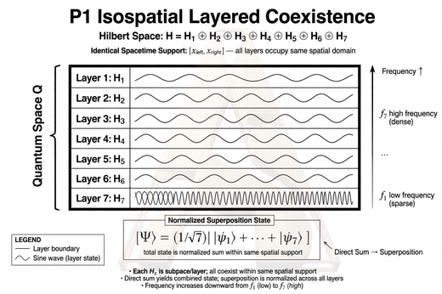

Diagram 1. Core geometric representation of isospatial reflexive structure.

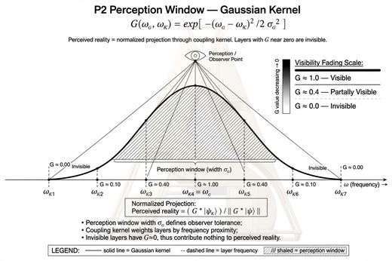

Diagram 2. Layered coexistence within a single spacetime coordinate.

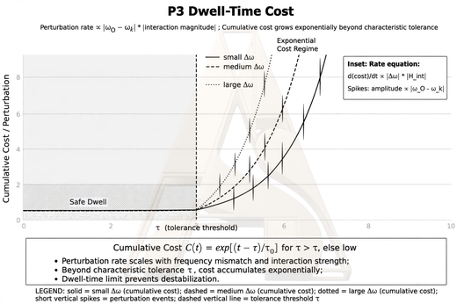

Diagram 3. Reflexive mirror sequence and frequency stratification.

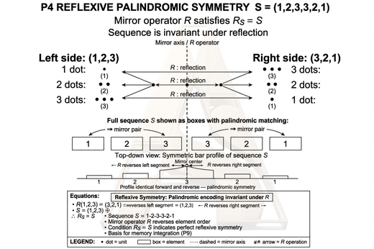

Diagram 4. Perception window and coupling kernel visualization.

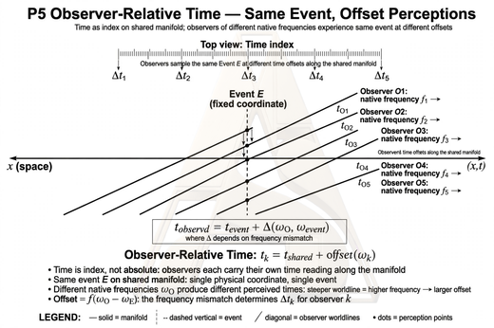

Diagram 5. Push-pull polarity and inter-layer dynamics.

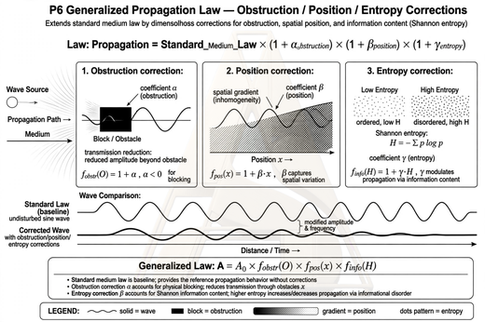

Diagram 6. On-off gating, hysteresis, and threshold behavior.

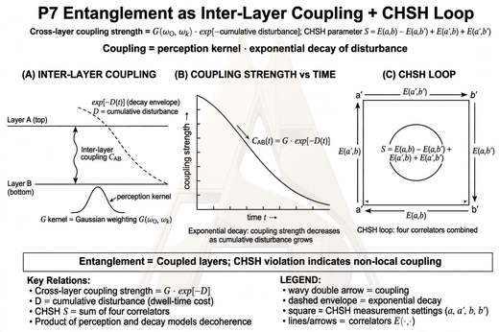

Diagram 7. Inter-layer entanglement and coupling network.

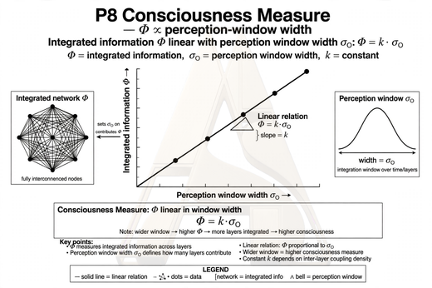

Diagram 8. Observer-relative time and slice structure.

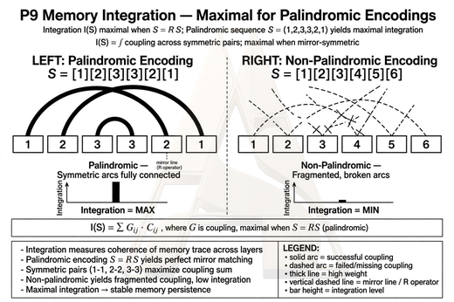

Diagram 9. Memory integration and palindromic encoding advantage.

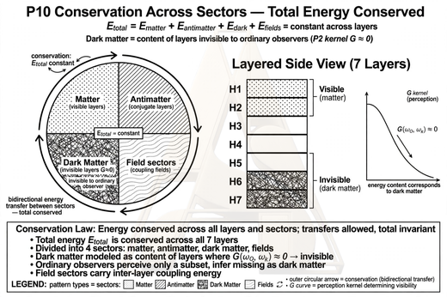

Diagram 10. Conservation across sectors and experimental architecture overview.

6. FORMAL MODEL - PRIMARY POSTULATES

P1. Isospatial Layered Coexistence

Let Q be a single quantum space with Hilbert space H equals the direct sum of H_k for k equals 1 to N. Each layer H_k occupies the identical spacetime support and is characterized by frequency band B_k. The total state is the normalized superposition of layer states. Layers are simultaneous components of one state. They are not separate timelines. They are not located on different Earths. They share every spacetime coordinate.

P2. Perception Window

An observer O possesses native frequency omega_O and bandwidth sigma_O. The coupling kernel G is the Gaussian exponential of minus the squared frequency difference divided by twice sigma_O squared. Perceived reality is the normalized projection of the total state through this kernel. Layers with G near zero are invisible. A portal occurs when G crosses a detection threshold. The portal is not a spatial doorway. It is a resonance condition at the same coordinates.

P3. Dwell-Time Cost of Presence

An observer with omega_O greater than omega_k may couple into layer k. Presence perturbs the layer state. The perturbation rate Gamma equals gamma_0 times the absolute frequency difference times interaction magnitude M(t). Cumulative disturbance D is the time integral of Gamma. Cost C equals C_0 times the
quantity e to the power of tau over tau_c minus one. Stability requires D less than or equal to D_crit. Exceeding the critical value corresponds to progressive disruption of the layer dynamical structure.

P4. Reflexive Palindromic Symmetry

Define the sequence S equals (s1, s2, s3, s3, s2, s1) and the mirror operator R that reverses index order. Then R S equals S. The generalization for an n-element structure is the sequence that reads identically forward and backward. Scale self-similarity under the scale operator holds up to bounded error. Molecular chirality is represented by the parity operator that maps left-handed to right-handed states.

P5. Observer-Relative Time

Time is treated as an index on the shared manifold, not a flow. Each observer carries an offset theta_O. For observers A and B the relation is t_A equals t_B plus kappa times the frequency difference. An event fixed in the block can lie in one observer past, another observer present, and a third observer future. Time travel in this model is a change of slice, a shift of theta_O, not an alteration of a flowing timeline.

P6. Generalized Propagation Law

Standard medium law is extended by three additional terms. Effective velocity equals c divided by the sum of refractive index, obstruction correction, position correction, and information-content correction. The information term is the Shannon entropy of the transmitted stream. Each correction is a small dimensionless quantity to be measured. Vacuum c remains constant.

P7. Entanglement as Inter-Layer Coupling

Subsystems in different layers share an entangled singlet-like state. Cross-layer coupling strength equals J_0 times the perception kernel times the exponential decay of disturbance over critical disturbance. The graph of nonzero couplings is the formal representation of inter-layer correlation. The CHSH parameter is the standard correlator combination, bounded by 2 for local theories and by 2 times square root of 2 for quantum mechanics.

P8. Consciousness Measure

Every system carries a nonnegative integrated-information value Phi computed from its causal structure. The falsifiable claim is that Phi correlates with the system perception-window width according to a linear relation with positive slope.

P9. Memory Integration

Memory integration of an encoded sequence is the weighted sum of inner products between elements and their positional mirrors. The sum is maximal when the sequence is palindromic. This yields the testable prediction that palindromic encodings produce the highest integration scores.

P10. Conservation Across Sectors

Total energy content is conserved across all layers and across the four sectors of matter, antimatter, dark matter, and field energy. Dark matter is modeled as the matter content of layers with near-zero perception kernel relative to ordinary observers. Interaction with perceived layers occurs through gravity and through the inter-layer coupling J_ab only.

7. EXTENDED MECHANISMS

P11 Push-Pull Polarity. Layer occupation obeys a rate equation driven by the difference of push and pull terms. The push-pull ratio equals 1 at balance. Deviation drives the perturbation rate of P3.

P12 On-Off Gate. Coupling is active only above a threshold. Smooth logistic gate and hysteretic switch are defined. Hysteresis width is the measurable variable.

P13 Curvature. Concave and convex local geometry are distinct dimensional aspects of the same spacetime support. Prediction: residual group delay depends on controlled local curvature after medium correction.

P14 Frame Recurrence. The reflexive sequence implies periodic return of frames. Prediction: palindromic stimuli produce higher rates of subjective recurrence reports and EEG recognition markers.

P15 Intuition Accuracy and Delay. Intuitive judgment is a rapid low-bandwidth readout from a broader perception window. Prediction: accuracy under time pressure correlates with Phi and sigma_O.

P16 Projection and Alignment. Projection maps internal state onto external layer. Alignment is match under the reflexive operator. Prediction: synchrony improves when stimuli respect palindromic structure.

8. EXPERIMENTAL BLUEPRINTS AND FALSIFICATION THRESHOLDS

All experiments are designed for preregistration, freezing of analysis scripts, and independent replication.

E1. Entanglement versus Environmental Frequency. Tests P1, P7, H1. Polarization-entangled photon pairs inside shielded enclosure with programmable EM drive. Measure CHSH at each frequency. Falsification if 95 percent CI of slope lies inside |dS/df| less than 0.02 per step.

E2. Palindromic Structure and Memory Integration. Tests P4, P9, H2. Three-arm randomized design: palindromic, ascending, shuffled. Primary outcome 24-hour delayed recall. Falsification if contrast CI lies inside |d| less than 0.2.

E3. Medium, Obstruction, Position, Information Dependent Propagation. Tests P6, H3. Time-of-flight across media and controlled information entropy. Falsification if 95 percent CI of eta_I lies within plus or minus 10 to the minus 6.

E4. Dwell-Time Cost. Tests P3, H4. Graded durations 15 to 120 minutes. Compare linear versus exponential cost models by AIC. Falsification if linear preferred by Delta AIC greater than 10.

E5 through E9. Hysteresis width, curvature residual delay, frame recurrence reports and EEG, intuition accuracy under time pressure, projection-alignment synchrony. Each carries quantitative equivalence bounds stated in the protocol section.

9. DIFFERENCES FROM EXISTING FRAMEWORKS

Factor | Standard Models | TIRD Position
Location of alternative realities | Branching timelines or spatially distant parallel Earths | Same spacetime coordinates. Isospatial.
Relation between layers | Sequential after measurement or non-communicating | Simultaneous and continuously coupled through J_ab
Symmetry principle | None formalized as operator | Palindromic mirror operator 1-2-3-3-2-1. Reflexive.
Push-pull, on-off, left-right | Binary opposites | Distinct dimensions stacked at same coordinate
Perception limit | Sensory band only | Gaussian kernel centered on observer native frequency
Cost of presence | Not modeled | Nonlinear dwell-time cost with critical disturbance threshold
Signal velocity | Depends on medium refractive index | Additional dependence on obstruction, position, and information content
Dark matter | Unknown particle or modified gravity | Matter content of layers with near-zero perception kernel
Falsifiability | Often interpretive | Nine protocols with quantitative equivalence bounds

10. RESULTS

No experiments have been performed and no data have been analyzed. This section contains no findings.

Item | Status
Study flow | No data collected
E1 primary outcome slope of CHSH versus frequency | No data collected
E2 primary outcome delayed recall contrast | No data collected
E3 primary outcome information correction estimate | No data collected
E4 primary outcome model comparison | No data collected
E5 through E9 outcomes | No data collected
Negative or null findings | None to report because no data exist
Protocol deviations | None because no data collection has occurred

11. DISCUSSION

The sole present contribution is the formal structure and the set of separable falsifiable predictions. The theory asserts isospatial coexistence of reflexive dimensions at a single spacetime coordinate. This assertion is presently unsupported by data.

A positive E1 result would support frequency-dependent coupling but would first need exclusion of drift and stray coupling. A positive E2 result would support palindromic encoding benefits but would not by itself demonstrate cross-layer effects. A positive E3 result would require reconciliation with the measured constancy of the vacuum speed of light. A positive E4 result would support a nonlinear fatigue cost and say nothing directly about other layers.

Branching models predict no frequency dependence in entanglement. The null model of E1 matches that prediction, so E1 discriminates between branching and isospatial frequency stratification. Parallel-universe
models place alternative realities elsewhere. TIRD places them here, at the same coordinates, distinguished only by frequency band and reflexive relation.

Recommended next steps in order of feasibility are E3, then E2, then E1, then E4, then the extended protocols according to resource availability.

12. CONCLUSION

The Theory of Isospatial Reflexive Dimensions yields quantitatively distinct predictions from standard quantum mechanics and standard propagation theory in four primary observables and five extended observables. It constitutes a formal falsifiable model of coexistent reflexive dimensions occupying a single spacetime coordinate. The theory is isospatial: layers share place and time. The theory is reflexive: each dimension is the mirror of the others under the operator that realizes the sequence 1-2-3-3-2-1. Empirical status is currently null. The theory stands or falls with the outcomes of the specified experiments. No postulate has empirical support yet.

13. TRANSPARENCY, ETHICS, AND INTEGRITY

Ethics approval has not yet been obtained. It is required before any human-participant protocol. Informed consent will be obtained for all human-participant protocols. Participant protection includes confidentiality, voluntary withdrawal, and risk minimization per approved protocol. Animal welfare is not applicable. Laser and electromagnetic safety review is required for the physical experiments. Participant data will be pseudonymized and stored with restricted access. Funding, competing interests, and author contributions will be stated accurately in the final submission version. No data exist. A data-availability statement matching actual arrangements will be added upon collection. A version-controlled repository will be created at preregistration. Protocol registration platform, identifier, and date will be recorded before data collection. Deviations and post-hoc analyses will be listed. Drafting assistance was used. Authors remain responsible for verifying all equations, claims, and citations before any submission. The manuscript represents a theoretical proposal. No data have been fabricated and no results are claimed.

14. REFERENCES

All entries require verification against the original publications before any formal submission.

1. Bell, J. S. (1964). On the Einstein Podolsky Rosen paradox. Physics, 1(3), 195-200.
2. Einstein, A., Podolsky, B., and Rosen, N. (1935). Can quantum-mechanical description of physical reality be considered complete? Physical Review, 47, 777-780.
3. Aspect, A., Dalibard, J., and Roger, G. (1982). Experimental test of Bell inequalities using time-varying analyzers. Physical Review Letters, 49, 1804-1807.
4. Hensen, B., and colleagues (2015). Loophole-free Bell inequality violation using electron spins separated by 1.3 kilometres. Nature, 526, 682-686.
5. Everett, H. (1957). Relative state formulation of quantum mechanics. Reviews of Modern Physics, 29, 454-462.
6. Tononi, G. (2008). Consciousness as integrated information: a provisional manifesto. Biological Bulletin, 215(3), 216-242.
7. Hameroff, S., and Penrose, R. (1996). Orchestrated reduction of quantum coherence in brain microtubules: a model for consciousness. Mathematics and Computers in Simulation, 40, 453-480.

15. FINAL RESEARCH DECLARATION

Research title: Theory of Isospatial Reflexive Dimensions (TIRD).
Project ID: EAV-TIRD-001.
Principal investigator: Angelica Pangan.
Organization: Earth Angel Ventures.
Version: 1.0.

The authors confirm that this manuscript represents a theoretical proposal and that no data, results, or approvals are claimed that do not exist. The theory asserts that multiple reflexive dimensions coexist at the same spacetime coordinate. It does not assert parallel Earths. It does not assert demonstrated inter-layer travel.

Lead author signature:
Date: October 20, 2026

Earth Angel Ventures Research Standard. The standard is not how extraordinary a claim sounds, but how reliably the evidence supports it and how well others can examine, challenge, reproduce, and build upon the work.

